Code | SSA | ACTUAL INCOME | ACTUAL EXP | CIRCLE-ACTUAL INCOME | CIRCLE - ACTUAL EXP | ZONE
14 | PDY | 4868 | 3500.00 | 1618 | -1129 | 1 | 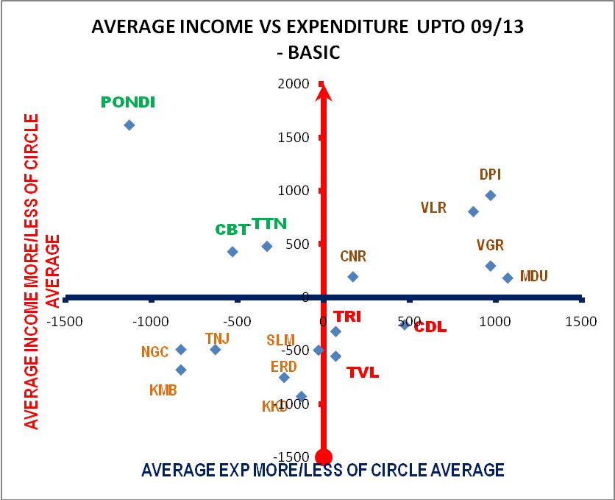
7 | CBT | 3679 | 4100.00 | 429 | -529 | 1
19 | TTN | 3729 | 4300.00 | 479 | -329 | 1
13 | NGL | 2761 | 3800.00 | -489 | -829 | 3
11 | KMB | 2570 | 3800.00 | -680 | -829 | 3
16 | TNJ | 2761 | 4000.00 | -489 | -629 | 3
6 | CNR | 3444 | 4800.00 | 194 | 171 | 2
8 | DPI | 4208 | 5600.00 | 958 | 971 | 2
20 | VLR | 4056 | 5500.00 | 806 | 871 | 2
18 | TRI | 2931 | 4700.00 | -319 | 71 | 4
15 | SLM | 2755 | 4600.00 | -495 | -29 | 3
9 | ERD | 2499 | 4400.00 | -751 | -229 | 3
17 | TVL | 2698 | 4700.00 | -552 | 71 | 4
21 | VGR | 3546 | 5600.00 | 296 | 971 | 2
5 | CDL | 2993 | 5100.00 | -257 | 471 | 4
10 | KKD | 2322 | 4500.00 | -928 | -129 | 3
12 | MA | 3432 | 5700.00 | 182 | 1071 | 2
 | CIRCLE | 3250.00 | 4629.00
ZONE I – MORE INCOME LESS EXPENDITURE
ZONE II – MORE INCOME MORE EXPENDITURE
ZONE III – LESS INCOME AND LESS EXPEDITURE
ZONE IV - LESS INCOME AND MORE EXPENDITURE

